**ASSIGNMENT NO.8.**

**Aim :-** Department maintains a student information. The file contains roll number, name, division and address. Allow user to add, delete information of student. Display information of particular employee. If record of student does not exist an appropriate message is displayed. If it is, then the system displays the student

**Program Code:-**

#include <iostream>

#include <fstream>

#include <cstring>

#include <iomanip>

#include<cstdlib>

#define max 50

using namespace std;

class Student

{

char name[max];

int rollNo;

int year;

int division;

char address[50];

friend class FileOperations;

public: Student()

{

strcpy(name,"");

rollNo=year=division=0;

strcpy(address,"");

}

Student(char name[max],int rollNo,int year,int division,char address[max])

{

strcpy(this->address,address);

strcpy(this->name,name);

this->division=division;

this->rollNo=rollNo;

this->year=year;

}

int getRollNo()

{

return rollNo;

}

void displayStudentData()

{

cout<<endl<<setw(3)<<rollNo<<setw(10)<<name<<setw(3)<<year<<setw(2)<<division<<setw(10)<<address;

}

};

class FileOperations

{

fstream file;

public:FileOperations(char *name)

{

//strcpy(this->name,name);

this->file.open(name,ios::in|ios::out|ios::ate|ios::binary);

}

void insertRecord(int rollNo,char name[max],int year,int division,char address[max])

{

Student s=Student(name,rollNo,year,division,address);

file.seekp(0,ios::end);

file.write((char*)&s,sizeof(Student));

file.clear();

}

void displayAllRecords()

{

Student s;

file.seekg(0,ios::beg);

while(file.read((char *)&s,sizeof(Student)))

{

s.displayStudentData();

}

file.clear();

}

void displayRecord(int rollNo)

{

Student s;

file.seekg(0,ios::beg);

void *p;

while(file.read((char *)&s,sizeof(Student)))

{

if(s.rollNo==rollNo)

{

s.displayStudentData();

break;

}

}

if(p==NULL)

throw "Element not present";

file.clear();

}

void deleteRecord(int rollNo)

{

ofstream newFile("new.txt",ios::binary);

file.seekg(0,ios::beg);

bool flag=false;

Student s;

while(file.read((char *)&s,sizeof(s)))

{

if(s.rollNo==rollNo)

{

flag=true;

continue;

}

newFile.write((char *)&s,sizeof(s));

}

if(!flag)

{

cout<<"Element Not Present";

}

file.close();

newFile.close();

remove("student.txt");

rename("new.txt","student.txt");

file.open("student.txt",ios::in|ios::ate|ios::out|ios::binary);

}

~FileOperations()

{

file.close();

cout<<"Closing file..";

}

};

int main()

{

ofstream newFile("student.txt",ios::app|ios::binary);

newFile.close();

FileOperations file((char *)"student.txt");

int rollNo,year,choice=0;

char division;

char name[max],address[max];

while(choice!=5)

{

//clrscr();

cout<<"\n*****Phone Book*****\n";

cout<<"1) Add New Record\n";

cout<<"2) Display All Records\n";

cout<<"3) Display by RollNo\n";

cout<<"4) Deleting a Record\n";

cout<<"5) Exit\n";

cout<<"Choose your choice : ";

cin>>choice;

switch(choice)

{

case 1 : //New Record

cout<<endl<<"Enter RollNo and name : \n";

cin>>rollNo>>name;

cout<<"Enter Year and Division : \n";

cin>>year>>division;

cout<<"Enter address : \n";

cin>>address;

file.insertRecord(rollNo,name,year,division,address);

break;

case 2 :

file.displayAllRecords();

break;

case 3 :

cout<<"Enter Roll Number";

cin>>rollNo;

try

{

file.displayRecord(rollNo);

}

catch(const char *str)

{

cout<<str;

}

break;

case 4:

cout<<"Enter rollNo";

cin>>rollNo;

file.deleteRecord(rollNo);

break;

case 5 :break;s

}

}

}

**Output Screenshots:-**

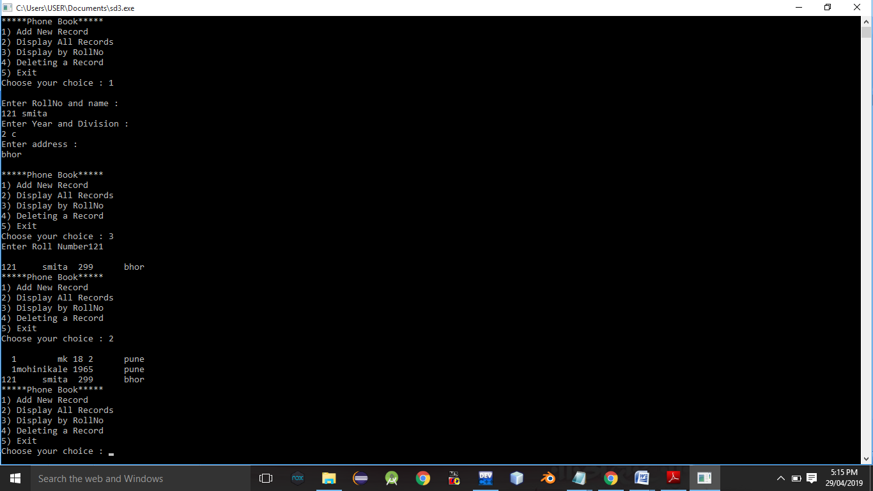

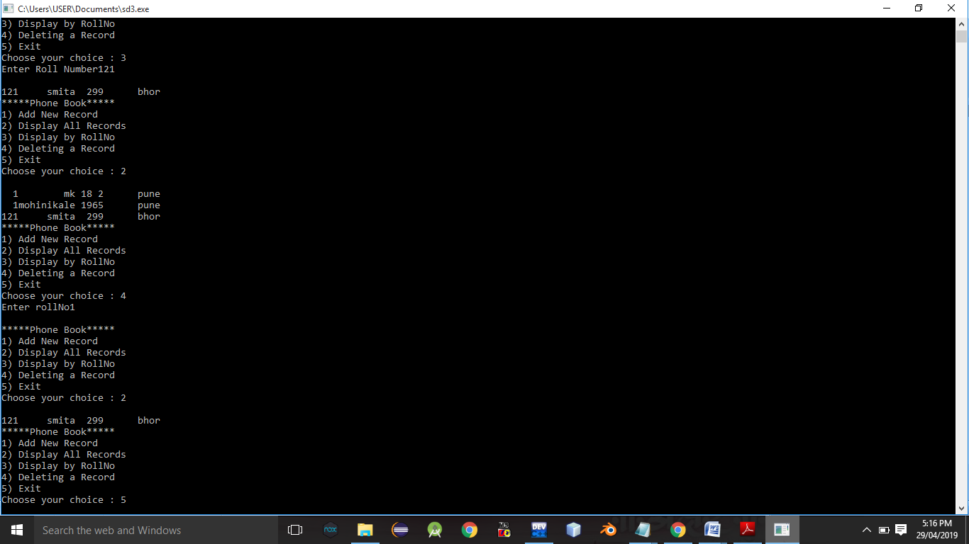

**Conclusion:-** Thus,this assignment implemented successfully.